**Industrial Internship Report on**

**“Quality Prediction in a Mining Process”**

**Prepared by**

**Shantanu Mishra**

|  |
| --- |
| *Executive Summary* |
| This report provides details of the Industrial Internship provided by upskill Campus and The IoT Academy in collaboration with Industrial Partner UniConverge Technologies Pvt Ltd (UCT).  This internship was focused on a project/problem statement provided by UCT. We had to finish the project including the report in 6 weeks’ time.  My project was on predicting silica impurity levels in iron ore concentrate from a flotation plant using machine learning techniques.  This internship gave me a very good opportunity to get exposure to Industrial problems and design/implement solution for that. It was an overall great experience to have this internship. |

**TABLE OF CONTENTS**

1 Preface 3

2 Introduction 4

2.1 About UniConverge Technologies Pvt Ltd 4

2.2 About upskill Campus 8

2.3 Objective 9

2.4 Reference 9

2.5 Glossary 10

3 Problem Statement 11

4 Existing and Proposed solution 12

5 Proposed Design/ Model 13

5.1 High Level Diagram (if applicable) 13

5.2 Low Level Diagram (if applicable) 13

5.3 Interfaces (if applicable) 13

6 Performance Test 14

6.1 Test Plan/ Test Cases 14

6.2 Test Procedure 14

6.3 Performance Outcome 14

7 My learnings 15

8 Future work scope 16

# Preface

During the six-week internship, I collaborated with UniConverge Technologies Pvt Ltd and Upskill Campus to address a key quality control challenge in iron ore processing.

The aim was to build a predictive system to estimate silica content in concentrate, enabling proactive adjustments in the flotation process.

Over six weeks, I balanced project work with weekly learning modules, applying theoretical concepts to practical industrial data.

# Introduction

## About UniConverge Technologies Pvt Ltd

A company established in 2013 and working in Digital Transformation domain and providing Industrial solutions with prime focus on sustainability and RoI.

For developing its products and solutions it is leveraging various**Cutting Edge Technologies e.g. Internet of Things (IoT), Cyber Security, Cloud computing (AWS, Azure), Machine Learning, Communication Technologies (4G/5G/LoRaWAN), Java Full Stack, Python, Front end**etc.

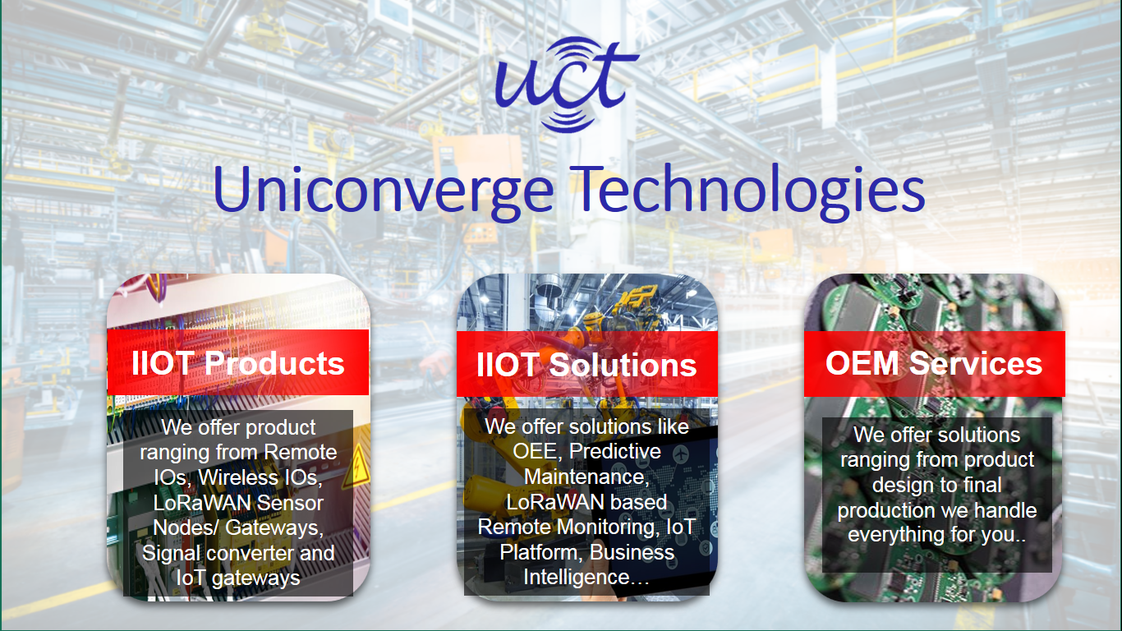

1. UCT IoT Platform **(****)**

**UCT Insight** is an IOT platform designed for quick deployment of IOT applications on the same time providing valuable “insight” for your process/business. It has been built in Java for backend and ReactJS for Front end. It has support for MySQL and various NoSql Databases.

* It enables device connectivity via industry standard IoT protocols - MQTT, CoAP, HTTP, Modbus TCP, OPC UA
* It supports both cloud and on-premises deployments.

It has features to  
• Build Your own dashboard  
• Analytics and Reporting  
• Alert and Notification  
• Integration with third party application(Power BI, SAP, ERP)  
• Rule Engine

 

1. **Smart Factory Platform (****)**

Factory watch is a platform for smart factory needs.

It provides Users/ Factory

* with a scalable solution for their Production and asset monitoring
* OEE and predictive maintenance solution scaling up to digital twin for your assets.
* to unleased the true potential of the data that their machines are generating and helps to identify the KPIs and also improve them.
* A modular architecture that allows users to choose the service that they what to start and then can scale to more complex solutions as per their demands.

Its unique SaaS model helps users to save time, cost and money.

 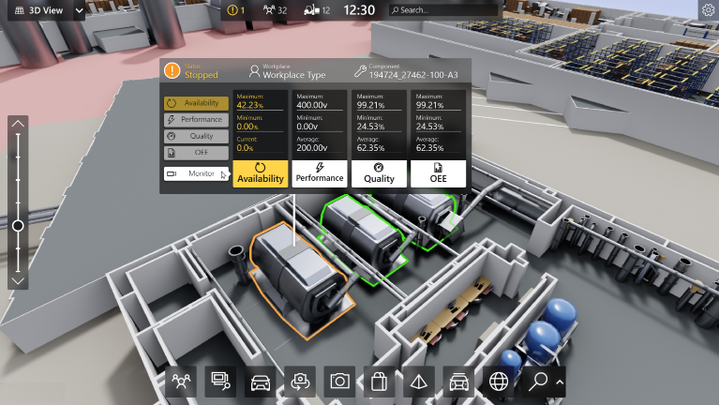

1. 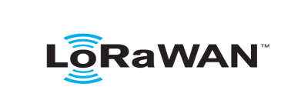 based Solution

UCT is one of the early adopters of LoRAWAN teschnology and providing solution in Agritech, Smart cities, Industrial Monitoring, Smart Street Light, Smart Water/ Gas/ Electricity metering solutions etc.

1. Predictive Maintenance

UCT is providing Industrial Machine health monitoring and Predictive maintenance solution leveraging Embedded system, Industrial IoT and Machine Learning Technologies by finding Remaining useful life time of various Machines used in production process.



## About upskill Campus (USC)

upskill Campus along with The IoT Academy and in association with Uniconverge technologies has facilitated the smooth execution of the complete internship process.

USC is a career development platform that delivers **personalized executive coaching** in a more affordable, scalable and measurable way.

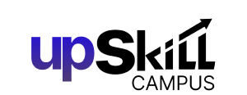

Seeing need of upskilling in self paced manner along-with additional support services e.g. Internship, projects, interaction with Industry experts, Career growth Services

<https://www.upskillcampus.com/>

upSkill Campus aiming to upskill 1 million learners in next 5 year

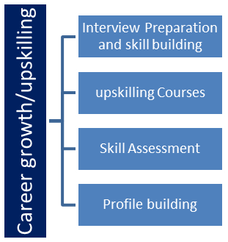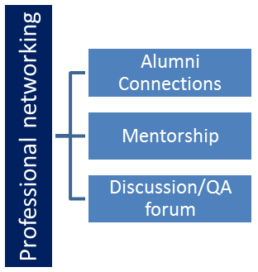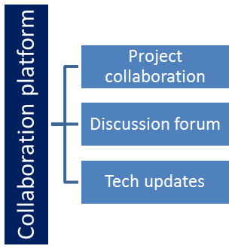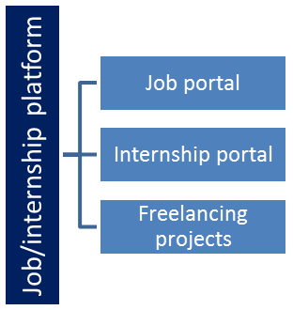

## The IoT Academy

The IoT academy is EdTech Division of UCT that is running long executive certification programs in collaboration with EICT Academy, IITK, IITR and IITG in multiple domains.

## Objectives of this Internship program

The objective for this internship program was to

 ☛ get practical experience of working in the industry.

 ☛ to solve real world problems.

 ☛ to have improved job prospects.

 ☛ to have Improved understanding of our field and its applications.

 ☛ to have Personal growth like better communication and problem solving.

# Problem Statement

In the assigned problem statement, this was the main job:

Accurately predicting silica impurity in iron ore concentrate is critical for optimizing flotation efficiency and reducing tailings.

The challenge was to handle mixed-frequency data (20-second and hourly samples) and develop a model that provides timely, reliable forecasts to support operational decisions.

# Existing and Proposed solution

Before this project, silica concentration control relied on periodic lab measurements and manual adjustments. Sampling was hourly, leading to delayed feedback and reactive corrections.

This approach often resulted in higher impurities, increased tailings, and suboptimal resource use. There was no predictive capability to anticipate process deviations in real time.  
  
The proposed solution forecasts silica percentage using machine learning on real-time sensor data.

By integrating data preprocessing, feature engineering, and XGBoost regression, the system delivers forecasts at fine time granularity.

Early prediction enables proactive parameter tuning, reduces impurity spikes, and minimizes environmental impact.

# Proposed Design/ Model

Data Preprocessing: Convert decimal commas to dots, impute missing values, and align multi-rate samples.  
  
Feature Engineering: Include feed quality, flow rates, level, air flow, and rolling statistics.  
  
Model: XGBoost Regressor trained on historical data.  
  
Multi-step Forecasting: Shift target to predict one hour ahead.  
  
Evaluation: Compare models with and without percentage Iron Concentrate feature.

# Performance Test

## Test Plan/ Test Cases

Split data into 80/20 train-test sets maintaining temporal order. Cases include minute-level prediction accuracy, one-hour-ahead forecasting, and evaluations with/without correlated features.

## Test Procedure

Load and preprocess data, train XGBoost models, evaluate using R² and RMSE metrics, and compare feature-inclusive and feature-excluded runs.

## 6.3 Performance Outcome

Both models achieved strong R² scores (>0.85) and low RMSE values, validating prediction reliability. Minute-level predictions captured rapid fluctuations, and one-hour-ahead forecasts provided actionable lead time.

# My learnings

Gained expertise in handling industrial multi-rate sensor data.  
Mastered parsing European-style decimals in pandas.  
Applied XGBoost for robust regression modeling.  
Explored the impact of correlated features on model generalization.  
Developed multistep forecasting strategies for operational needs.  
Learned to interpret and leverage feature importance for process improvements.  
Balanced model complexity with computational efficiency.  
Understood the environmental benefits of proactive impurity control.  
Enhanced skills in time series regression and validation techniques.  
Strengthened data-driven decision-making capability in industrial contexts.

# 8 Future work scope

Integrate real-time data streams for continuous impurity forecasting.

Extend prediction models to forecast multiple hours in advance.

Explore deep learning techniques to enhance model accuracy.

Incorporate additional variables like ore grade and chemical additives.

Develop an interactive dashboard for live monitoring and alerts.

Apply the solution to other minerals and processing units for scalability.

## 9 Code submission (Github link)

https://github.com/Shantanu2003-alt/Quality-Prediction-in-Mining-Plant